Executive Board Meeting
Tuesday, 15-May-2018 – 5:30 PM
CVSWMD Offices: 137 Barre Street, Montpelier VT

Minutes
- Chairman Fred Thumm, Vice-Chair Lee Cattaneo and member Peter Carbee met at 5:30, joined by the General Manager. Members Bill Powell and Matt Levin were unable to attend. The Chair called the meeting to order at 5:40.
- Agenda Revisions – The GM provided the members with a quick overview of the last minute Legislative ups and downs of S.285, the bill originally introduced as Act 148 update measures. There was brief discussion of escheats, the crisis in recyclables (especially mixed paper), and related developments. No action was taken.
- Approval of the Executive Board minutes – Members reviewed Executive Board minutes of April 17, 2018. Lee Cattaneo made a motion to accept the minutes; passed unanimously at 5:42 PM.
- Discussion of Proposed Amendments: FY19 Budget – The GM walked the members through the four pages detailing the FY19 budget (as approved by the Board in September 2017), and proposed changes to it. Highlights of the review are as follows:
  - Westcott pointed to a continued moderate growth trend in SW subject to the District surcharge, and the resultant increase in projected Surcharge revenues for the year.
  - He pointed out that the EPA and USDA grants which commenced October 1, 2018 started slowly, with underspending (relative to budget) for the first six grant months, and project through June 30. As a result, FY19 projections reflect an increase from 25% of the budgeted grant revenues and expenditures to an estimated 35%. Budget line 4060 (grant revenues) and multiple expense lines are increased. Members asked the GM to prepare a separate sheet detailing the proposed changes in grant revenues and expenses for review by Board members at the June meeting, so as to reduce confusion.
  - With respect to line 5000 (cost of compost equipment sold) Lee Cattaneo contrasted the figures in the budget with the Outreach workplan update which had just been presented to the Program Advisory Committee by Outreach Director Cass Hemenway. Westcott said he’d review the figures with her, so as to reduce the potential for Board confusion on this point.
Executive Board members expressed general approval and asked the GM to present the proposed changes for Board approval in June.
- Grant Approval: DEC Truck Wrap Grant – The GM shared with the Executive Board the letter from VT-DEC awarding $3,250 in Solid Waste Assistance funds for purposes of revising the message wrapping the District box truck. Funds will be presented for approval to the Board as part of the FY19 budget revision at the June meeting.
- Staff Compensation Review – The GM reviewed with the Executive Board (acting in its capacity as Personnel Committee) the recent history of Staff Compensation Reviews done for the District, and the recommendation made last year that another review should be done, in order to assure District staff are offered a scale of fair compensation equivalent to that offered by other organizations. The GM and Executive Board discussed the timing difficulties related to completing annual performance reviews, to awarding the Cost of Living and optional Merit/Performance wage increased covered by District policy, and to schedule the utilization of an external consultant to research and recommend Staff Compensation.
Following this discussion, Lee Cattaneo suggested the following:
- A COLA adjustment should be provided to all staff, as specified in policy, effective July 1.
- The GM should complete all performance review activities over the summer, and recommend a funding level to the Personnel Committee, assuring staff that any Merit/Performance increase approved by the Committee or the Board will be provided no later than September, retroactive to July 1.
- The GM should complete re-drafting of all job descriptions, review by the Personnel Committee, and solicitation of a Review consultant as soon as possible. The goal should be to have the Review work completed by summer-end, or as soon as possible thereafter. Staff should be informed that any compensation adjustments resulting from Board adoption of a revised pay schedule will be made as soon as possible following Board action.
Peter Carbee made a motion to approve Lee’s suggestion; passed unanimously at 6:50 PM.
- Review of proposed Policy updates – DISCUSSION ITEM
  - (Unified) Personnel Policy Updates – The GM reviewed with the Executive Committee the “housekeeping” changes which staff suggest in this policy. There was some discussion, and the members agreed that the Board should be presented with excerpts highlighting changes, for their approval.
  - (Unified) Financial Policy Updates – Members discussed these updates briefly and asked the GM to provide the Board with a complete copy, with changes marked, for their approval at the June meeting.
- Other Business – Announcements/discussion
- Adjourn -- At 6:49 PM motion to adjourn was made by Peter Carbee, seconded, and passed unanimously.
Respectfully submitted,
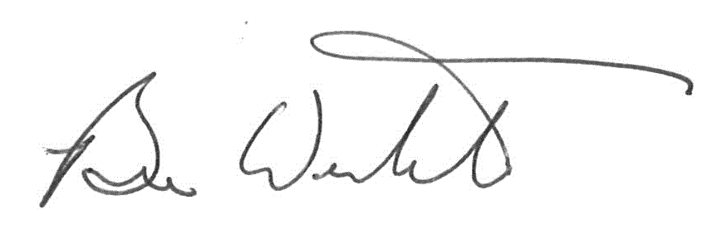
Bruce Westcott, General Manager

